Text / Sentiment Analysis

Definition
# Source: AI Source: Provided by: [Data Path: Persons Table -> ID Column: 1, Name_En Column: Motasem Essam] -> From: [Chatgpt (GPT‑5 Mini)] on [12/10/2025]
Text / Sentiment Analysis is the process of examining textual data (like reviews, comments, social media posts, or documents) to extract insights, sentiments, opinions, or patterns.
- Often used in customer feedback, social media monitoring, or product reviews.
- Can detect whether text expresses positive, negative, or neutral sentiment.
Key idea:
It’s like reading a large number of customer reviews and summarizing how people feel about a product without reading each review individually.

Characteristics of Text / Sentiment Analysis
# Source: AI Source: Provided by: [Data Path: Persons Table -> ID Column: 1, Name_En Column: Motasem Essam] -> From: [Chatgpt (GPT‑5 Mini)] on [12/10/2025]
- Works on unstructured data such as text, tweets, emails, or reviews
- Uses natural language processing (NLP), machine learning, or lexicon-based methods
- Can classify sentiments, emotions, topics, or keywords
- Helps with customer experience management, brand monitoring, and market research
- Often combined with visual analysis to create sentiment dashboards

Examples
# Source: AI Source: Provided by: [Data Path: Persons Table -> ID Column: 1, Name_En Column: Motasem Essam] -> From: [Chatgpt (GPT‑5 Mini)] on [12/10/2025]
- Customer Reviews: Analyze product reviews to find overall satisfaction.
  - Example: "The laptop is fast and reliable." → Positive
- Social Media Monitoring: Track brand sentiment across tweets.
  - Example: Tweet: "I hate the new update!" → Negative
- Survey Responses: Extract key themes or opinions from open-ended responses.
- Support Tickets: Identify frequent issues in customer complaints.

Advantages
# Source: AI Source: Provided by: [Data Path: Persons Table -> ID Column: 1, Name_En Column: Motasem Essam] -> From: [Chatgpt (GPT‑5 Mini)] on [12/10/2025]
- Allows analysis of large amounts of text quickly
- Detects trends, opinions, and sentiments automatically
- Supports business decisions and customer service improvements
- Can be combined with visual dashboards for easier interpretation
- Reduces manual effort of reading all textual data

Disadvantages
# Source: AI Source: Provided by: [Data Path: Persons Table -> ID Column: 1, Name_En Column: Motasem Essam] -> From: [Chatgpt (GPT‑5 Mini)] on [12/10/2025]
- Can be inaccurate due to sarcasm, irony, or ambiguous language
- Requires advanced NLP tools or programming knowledge for best results
- May misinterpret context, leading to wrong sentiment classification
- Text data often noisy or inconsistent, requiring cleaning
- Processing large datasets can be computationally intensive

Example Section
# Source: AI Source: Provided by: [Data Path: Persons Table -> ID Column: 1, Name_En Column: Motasem Essam] -> From: [Chatgpt (GPT‑5 Mini)] on [12/10/2025]
A company collects customer feedback about a new smartphone:
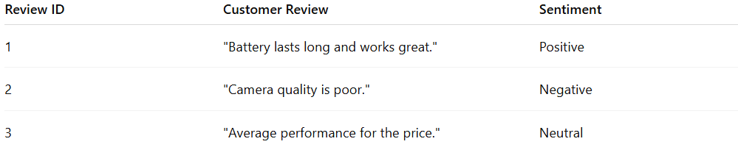
Review ID | Customer Review | Sentiment
1 | "Battery lasts long and works great." | Positive
2 | "Camera quality is poor." | Negative
3 | "Average performance for the price." | Neutral
Analysis:
- Sentiment analysis classifies reviews into Positive, Negative, Neutral
- Visualization (pie chart) shows:
  - Positive: 33%
  - Negative: 33%
  - Neutral: 33%
- Company identifies areas for improvement (camera quality) and highlights strengths (battery life).

